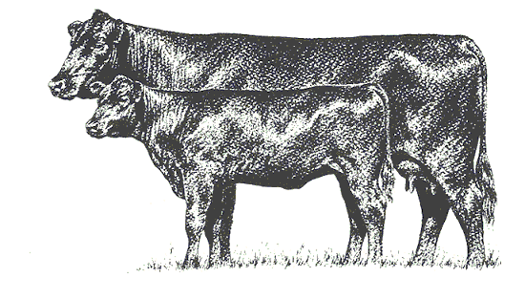
2018 ILA
Membership Renewal
Now is the time to be thinking about memberships for the 2017 Indiana Limousin Association. Adult membership fees will remain $25 per couple or individual. This will also get you into the 2018 Directory. If you know of someone who would be interested in joining us in 2018, please let us know! We will be happy to get information out to them to become members as well! (Juniors will pay dues at Beef Congress or Field Day.)
A second phone number and email are used for contacting our members, but if you would also like to include those in the 2017 Directory, please checkmark the boxes after filling in that information.
Please complete the info below, return with a $25 check made out to the Indiana Limousin Association and mail by February 1, 2018 (or bring to the Annual Meeting) to:
Attn: Kayla Tobias 2111 West 246 Street Sheridan, IN 46069
If questions contact Kayla: 317-379-2853
Please Print
Name:

Farm Name:

Address:

City, Zip:

Home Ph:

Mobile Ph:

Other Ph? |  | Check to include in directory
Email: |  | Check to include in directory

Kayla, please send a copy of this form and ILA information to:
Name:
Street Address:
City, Zip Code:

Please return all forms and payment in the enclosed envelope and mail back to Kayla Tobias.

